**Question 1**

Body Mass Index (BMI) is a measure of health on weight. It can be calculated by taking your weight in kilograms and dividing by the square of your height in meters. The interpretation of BMI for people 16 years or older is as follows:

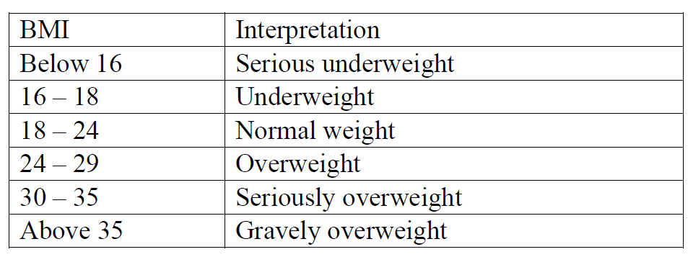

Develop a C++ application to get the weight and height of a person and print appropriate information.

**CPP Code:**

#include<iostream>

#include<conio.h>

using namespace std;

int main()

{

float w,h,bmi;

cout<<endl<<"Enter your weight in kg: ";

cin>>w;

cout<<"Enter your haight in meters: ";

cin>>h;

bmi=w/(h*h);

cout<<"Calculated BMI: "<<bmi<<endl;

cout<<"Interpretation: ";

if(bmi<16)

cout<<"Serious underweight";

else if(bmi<18)

cout<<"Underweight";

else if(bmi<24)

cout<<"Normal weight";

else if(bmi<29)

cout<<"Overweight";

else if(bmi<35)

cout<<"Seriously overweight";

else

cout<<"Gravely overweight";

cout<<endl<<endl;

return 0;

}

**JAVA Code:**

import java.util.Scanner;

public class q1

{

public static void main(String[] args)

{

float w, h, bmi;

Scanner in = new Scanner(System.in);

System.out.print("Enter your weight in kg: ");

w = in.nextFloat();

System.out.print("Enter your haight in meters: ");

h = in.nextFloat();

bmi = w / (h * h);

System.out.println();

System.out.println("Calculated BMI: " + bmi);

System.out.print("Interpretation: ");

if (bmi < 16)

System.out.println("Serious underweight");

else if (bmi < 18)

System.out.println("Underweight");

else if (bmi < 24)

System.out.println("Normal weight");

else if (bmi < 29)

System.out.println("Overweight");

else if (bmi < 35)

System.out.println("Seriously overweight");

else

System.out.println("Gravely overweight");

}

}

**OUTPUT:**

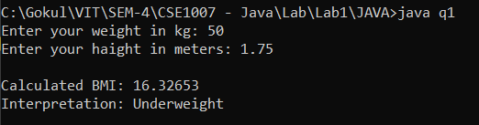

**Question 2**

**Write a method that will return the sum of all digits in an integer. The method signature is as follows: (for example, sum(1234) returns 10 and sum(12345) returns 15.)**

**public static int sum(int number)**

**Write a C++ program to test harness the above method.**

**CPP Code:**

#include<iostream>

#include<conio.h>

using namespace std;

int sum(int n)

{

int s=0,d;

while(n>0)

{

d=n%10;

s+=d;

n=n/10;

}

return s;

}

int main()

{

int n;

cout<<endl<<"Enter a number: ";

cin>>n;

cout<<"Sum: "<<sum(n)<<endl<<endl;

return 0;

}

**JAVA Code:**

import java.util.Scanner;

public class q2 {

static int sum(int n) {

int s = 0, d;

while (n > 0) {

d = n % 10;

s += d;

n = n / 10;

}

return s;

}

public static void main(String[] args) {

Scanner in = new Scanner(System.in);

int n;

System.out.print("Enter a number: ");

n = in.nextInt();

System.out.println("Sum: " + sum(n));

}

}

**OUTPUT:**

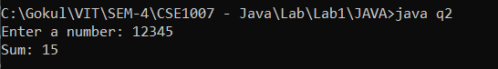

**Question 3**

**Write a method distance to calculate the distance between two points (x1, y1) and (x2, y2). All numbers and return values should be of type double.**

**Incorporate this method in a C++ application that enables the user to enter the coordinates of the points and print the distance between them.**

**CPP Code:**

#include<iostream>

#include<conio.h>

#include<math.h>

using namespace std;

float distance(int x1, int y1, int x2, int y2)

{

float d=sqrt(pow(x2 - x1, 2) + pow(y2 - y1, 2));

return d;

}

int main()

{

int x1,y1,x2,y2;

cout<<endl<<"Enter x-coordinate of 1st point: ";

cin>>x1;

cout<<"Enter y-coordinate of 1st point: ";

cin>>y1;

cout<<"Enter x-coordinate of 2nd point: ";

cin>>x2;

cout<<"Enter y-coordinate of 2nd point: ";

cin>>y2;

cout<<endl<<"Distance between 2 points: "<<distance(x1,y1,x2,y2)<<endl<<endl;

return 0;

}

**JAVA Code:**

import java.util.Scanner;

public class q3

{

static double distance(int x1, int y1, int x2, int y2)

{

double d=Math.sqrt(Math.pow(x2 - x1,2 ) + Math.pow(y2 - y1, 2));

return d;

}

public static void main(String[] args)

{

Scanner in= new Scanner(System.in);

int x1,y1,x2,y2;

System.out.print("Enter x-coordinate of 1st point: ");

x1=in.nextInt();

System.out.print("Enter y-coordinate of 1st point: ");

y1=in.nextInt();

System.out.print("Enter x-coordinate of 2nd point: ");

x2=in.nextInt();

System.out.print("Enter y-coordinate of 2nd point: ");

y2=in.nextInt();

System.out.println();

System.out.println("Distance between 2 points: "+distance(x1,y1,x2,y2));

}

}

**OUTPUT:**

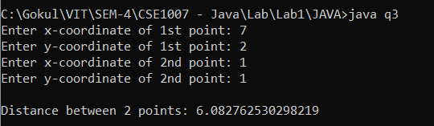

**Question 4**

**The area is the two-dimensional amount of space that an object occupies. Area is measured along the surface of an object and has dimensions of length squared; for example, square feet of material, or centimetres squared.**

**The area of a rectangle is equal to the height h times the base b; A = h * b**

**The equation for the area of a trapezoid is one half the sum of the top t and bottom b times the height h; A = h * [ t + b ] / 2**

**The area of a circle is A = pi * r2, where pi = 3.14 and r = radius.**

**Develop a program in C++ using function overloading for computing area of a rectangle, a trapezoid and a circle by a common function name ComputeArea() with different signature. Assume pi = 3.14.**

**CPP Code:**

#include <iostream>

#include<string.h>

using namespace std;

float area(float h, float b)

{

return h*b;

}

float area(float t, float b, float h)

{

return h*((t+b)/2);

}

float area(float r)

{

return 3.14*r*r;

}

int main()

{

int choice; float A;

cout<<endl<<"1.Rectangle 2.Trapezoid 3.Circle"<<endl<<"Enter your choice: ";

cin>>choice;

if(choice==1)

{

float hR,bR;

cout<<"Enter height of rectangle: ";

cin>>hR;

cout<<"Enter base of rectangle: ";

cin>>bR;

A=area(hR,bR);

}

else if(choice==2)

{

float tT,hT,bT;

cout<<"Enter top of trapezoid: ";

cin>>tT;

cout<<"Enter bottom of trapezoid: ";

cin>>bT;

cout<<"Enter height of trapezoid: ";

cin>>hT;

A=area(tT,bT,hT);

}

else if(choice==3)

{

float rC;

cout<<"Enter radius of circle: ";

cin>>rC;

A=area(rC);

}

else

cout<<"Invalid Choice"<<endl<<endl;

cout<<"Area: "<<A<<endl<<endl;

}

**JAVA Code:**

import java.util.Scanner;

public class q4

{

static double area(double h, double b)

{

return h*b;

}

static double area(double t, double b, double h)

{

return h*((t+b)/2);

}

static double area(double r)

{

return 3.14*r*r;

}

public static void main(String[] args)

{

Scanner in=new Scanner(System.in);

int choice;

double A=0;

System.out.println("1.Rectangle 2.Trapezoid 3.Circle");

System.out.print("Enter your choice: ");

choice=in.nextInt();

if(choice==1)

{

double hR,bR;

System.out.print("Enter height of rectangle: ");

hR=in.nextDouble();

System.out.print("Enter base of rectangle: ");

bR=in.nextDouble();

A=area(hR,bR);

}

else if(choice==2)

{

double tT,hT,bT;

System.out.print("Enter top of trapezoid: ");

tT=in.nextDouble();

System.out.print("Enter bottom of trapezoid: ");

bT=in.nextDouble();

System.out.print("Enter height of trapezoid: ");

hT=in.nextDouble();

A=area(tT,bT,hT);

}

else if(choice==3)

{

double rC;

System.out.print("Enter radius of circle: ");

rC=in.nextDouble();

A=area(rC);

}

else

System.out.println("Invalid Choice");

System.out.println("Area: "+A);

}

}

**OUTPUT:**

